Department of Health  PROCEDURE |  | 

P009-ETH: Exemptions from Ethics Review
SDMS Id Number: | P23/344
Overarching Policy: | Research Governance Policy Framework(P20/299) &  Low Risk Research Procedure (P22/332)
Effective From: | December 2023
Replaces Doc. No: | NA
Custodian and Review Responsibility: | Research Governance Office, Clinical Quality Regulation and Accreditation (CQRA)
Contact: | Dr Barbara Kameniar, Research Ethics Officer
Applies to: | All Staff
Review Date: | December 2025
Key Words: | Research Ethics, Exemption, Ethics Approval, Research Governance
Routine Disclosure: | Yes

Approval
Prepared by | Dr Barbara Kameniar | Research Ethics Officer | 61654004 | 11 September 2023
Through | Dr Raisa Cassim | Research Governance Coordinator | NA | 29 September 2023
Through | Research Innovation Subcommittee | RISc Membership | NA | 15 November 2023
Cleared by | Dr Alison Turnock | Deputy Chief Medical Officer | 6166 1322 | 26 November 2023

Revision History
Version | Approved By Name | Approved By Title | Amendment Notes
1.0

Introduction
- This procedure sets out how the exemption from ethics review is determined within the Tasmanian DoH and the processes to be followed to ensure researchers are provided with a notice of exemption when appropriate.
- Some research, QI, and audit projects undertaken within the Tasmanian Department of Health (DoH), including the Tasmanian Health Services (THS) and by DoH/THS staff will be of lower risk, not involve the use of personal information, and not require ethics review. However, DoH/THS staff may wish to publish findings from such projects.
- Many journals require review of research by a Research Ethics Committee or evidence of an exemption from review.
- The National Statement on Ethical Conduct in Human Research 2023 (the National Statement) informs and guides all procedures related to ethics review of research, QI, and audit projects within the DoH/THS.
- In setting out national standards and core responsibilities for the ethical design, review and conduct of human research the National Statement notes that institutions responsible for research are charged with determining when the research might be eligible for a grant of exemption from ethics review.
- Note, audits undertaken for the following reasons are automatically exempt from ethics review and therefore not included in this procedure:
  - Audits required for compliance by the Federal or State Government
  - Audits which are required for compliance with regulating bodies (e.g., National Association of Testing Authorities, Australia)
  - Audits pertaining to health service accreditation process (e.g., meeting requirements of National Safety and Quality Health Service Standards)
  - Audits which evaluate compliance with documented clinical pathways/guidelines/standards (e.g., many Quality Improvement (QI) audit projects)
- This procedure will be revised from time-to-time in response to amendments to the State and National documents that inform it.
- This procedure will be evaluated through the Policy Effectiveness Program.

Mandatory Requirements
- This procedure must only be used when the research does NOT involve the use of personal information without consent.
- If the research involves the use of personal information without consent a waiver of consent must be sought from an HREC (see Attachment 1 and Guidelines under Section 95 of the Privacy Act 1988).
- Records of any exemptions to ethics review must be securely stored.
- Research eligible for exemption must carry no more than a lower risk to participants or the community and must satisfy at least one of the conditions outlined in the National Statement and listed below:
  - ‘The research involves the use of collections of information or data from which all personal identifiers have been removed prior to being received by the researchers and where researchers explicitly agree:
    - not to attempt to re-identify those with whom the information or data is associated;
    - to take all reasonable steps to prevent re-identification of the information or data for unauthorised purposes or access to the information or data by those who are not authorised; and
    - that any sharing of any research data during or after the project will not create any additional risks to re-identification of the information or data
  - the research is restricted to surveys and observation of public behaviour using information that was or will be collected and recorded without personal identifiers and is highly unlikely to cause distress to anyone associated with the information or the outcomes of the research;
  - is conducted as part of an educational training program in which the research activity is for training purposes only and where any outcomes or documentation are for program use only;
  - the research uses only information that is publicly available through a mechanism set out by legislation or regulation and that is protected by law, such as mandatory reporting information, information obtained from registries of births and deaths, coronial investigations or reports of the Australian Bureau of Statistics’ (NS paras 5.1.15-5.1.17).

Roles and Responsibilities/Delegations

Researchers/Investigators are responsible for:
- Checking the National Statement (paras 5.1.15 – 5.1.18 and Chapter 3.1, Element 4) prior to submission of an application for exemption, to ensure their project is eligible for exemption.
- Contacting Supporting Departments to discuss whether their project can be supported (if applicable).
- Contacting the Research Ethics Office to discuss any ethical issues that may arise from the proposed project.
- Submitting a copy of their research, QI, or audit project description/protocol along with a completed Application for Exemption form and any additional forms applicable to the application (e.g., if accessing Digital Medical Records, a completed HIMS Data Access and Request Form).
- Conducting their research, QI, or Audit projects in line with the Project Description/Protocol and conditions set out in the Notice of Exemption.

Supporting Departments are responsible for:
- Providing advice about whether the proposed project can be supported.
- Providing the required resources and/or support required for the researcher/investigator to undertake the research, QI, or audit project.

Research Ethics Office is responsible for:
- Providing advice about eligibility criteria for exemption from ethics review.
- Ensuring applications are forwarded to the Low Risk Human Research Ethics Committee (LRR Ethics Committee) Chair or proxy within 2 working days of receipt.
- Providing a response to applicants as directed by the Chair or proxy.
- Keeping a record of all exemption requests, outcomes, and communications.
- Providing a report of all requests and outcomes to the LRR Ethics Committee.

The Chair or Proxy is responsible for:
- Reading applications for exemption and determining whether the project meets the requirements for an exemption as described in the National Statement (paras 5.1.15-5.1.18).
- Directing the Research Ethics Officer on how to respond to the applicant. Responses can be either:
    - Exemption Granted
  - A notice of exemption to be provided.
    - Exemption Not Granted
  - A notice of exemption not granted, with an explanation for why the exemption was not granted to be provided.
  - The explanation should reference appropriate sections in the National Statement to support reasoning for the determination.

Procedure
- Researchers must submit a copy of their research, QI, or audit project description/protocol along with a completed Application for Exemption form (see Attachment 2) and any other forms applicable to the application via email to research.ethics@health.tas.gov.au with the subject line “Request for Exemption: [short study title]”.
- Upon receipt of the application, a Research Ethics Officer will review all documentation to ensure the application is eligible for consideration. If documentation is missing or the application does not provide sufficient responses to support an informed determination the application will be determined to be ineligible and the Research Ethics Officer will request additional information from the researcher/investigator via email from research.ethics@health.tas.gov.au with the subject line “Request for Exemption: [short study title] – Further Information Required”.
- Assessment of eligibility should occur within two working days.
- If the application is eligible for consideration the Research Ethics Officer will forward the application to the Chair or a proxy for determination as soon as practicable.
- The Chair or proxy will read the application and determine whether the project is exempt from ethics review.
- If the request for exemption meets the mandatory requirements set out in the National Statement and shown above, the Chair or Proxy will request, via email, that the Research Ethics Officer provide the researcher/investigator with a Notice of Exemption from Ethics Review form.
- If the request for exemption does not meet the mandatory requirements set out in the National Statement and shown above, the Chair or Proxy will request, via email, that the Research Ethics Officer provide the researcher/investigator with a Notice of Exemption Not Granted form.
- If researchers wish to discuss the outcome of the application, they must do so in writing, via email to research.ethics@health.tas.gov.au with the subject line “Request for Exemption – Request to Discuss Outcome”.
- The Research Ethics Officer will pass all such requests to the Chair or proxy who made the determination.

Key Performance Indicators
- 95% of applications for exemption from ethics review are assessed for eligibility within two working days of receipt.
- 95% of Certificates of Exemption are issued within seven working days of eligibility being confirmed.

Key Definitions (taken from the Privacy Act 1988)
- Health information means:
  - Information or an opinion about:
    - the health or a disability (at any time) of an individual; or
    - an individual’s expressed wishes about the future provision of health services to him or her; or
    - a health service provided, or to be provided, to an individual that is also personal information or;
  - Other personal information collected to provide, or in providing, a health service; or
  - Other personal information about an individual collected in connection with the donation, or intended donation, by the individual of his or her body parts, organs or body substances; or
  - Genetic information about an individual in a form that is, or could be, predictive of the health of the individual or a genetic relative of the individual.
- De-identified means: personal information is de-identified if the information is no longer about an identifiable individual or an individual who is reasonably identifiable.
- Personal information means information or an opinion about an identified individual, or an individual who is reasonably identifiable:
  - whether the information or opinion is true or not; and
  - whether the information or opinion is recorded in a material form or not.
- Sensitive information means:
  - information or an opinion about an individual’s:
    - racial or ethnic origin; or
    - political opinions; or
    - membership of a political association; or
    - religious beliefs or affiliations; or
    - philosophical beliefs; or
    - membership of a professional or trade association; or
    - membership of a trade union; or
    - sexual orientation or practices; or
    - criminal record;
that is also personal information; or
    - health information about an individual; or
    - genetic information about an individual that is not otherwise health information; or
    - biometric information that is to be used for the purpose of automated biometric verification or biometric identification; or
    - biometric templates.
NB: The definition of Sensitive Information is included here to assist researchers/investigators in determining whether specific combinations of ‘sensitive’ data might lead to personal identification.

Related Documents/Legislation
- Flowchart s95 guidelines (4).pdf
- Guidelines under section 95 of The Privacy Act (4).pdf
- National Statement on Ethical Conduct in Human Research 2023 | NHMRC
- Personal Information Protection Act 2004 View - Tasmanian Legislation Online
- Privacy Act 1988 (legislation.gov.au)

Attachments
- Determining whether the S95 Guidelines apply – Flowchart.
- Master of Application for an Exemption from Ethics Review form.

Attachment 1
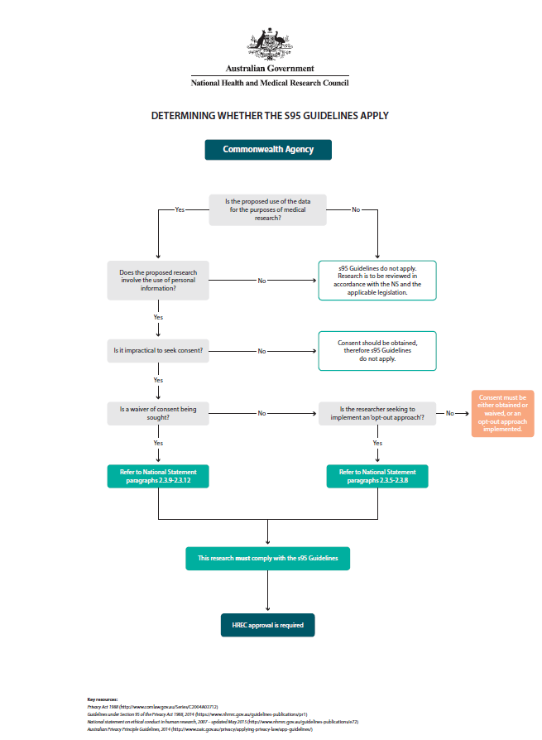
Department of Health
Application for an Exemption from Ethics Review

Attachment 2
Date:
Study Title:
Name/s of Investigator/s:

- What is the level of risk associated with the project? (Refer to National Statement Chapter 2.1)
Lower risk to participants or the community
Higher risk to participants or the community
If you answered ‘higher risk’ you cannot apply for an exemption from Ethics Review.
- Does the research involve the use of personal information?
Personal information means information or an opinion about an identified individual, or an individual who is reasonably identifiable:
- Whether the information or opinion is true or not; and
- Whether the information or opinion is recorded in a material form or not.
Yes
No
If you answered ‘yes’ to question (2) you must complete a Human Research Ethics Application (HREA) in REGIS or an application for a waiver and submit the application to an HREC – contact Ethics and Governance Office to discuss HREC most applicable to your project. (See also, NS paras 2.3.9 - 2.3.12)
- Tick the box(es) to indicate the eligibility criteria under which you are claiming exemption:
The research involves the use of collections of information or data from which all personal identifiers have been removed prior to being received by the researchers and where the researchers explicitly agree:
- Not to attempt to re-identify those with whom the information or data is associated.
- To take all reasonable steps to prevent re-identification of the information or data for unauthorised purposes or access to the information or data by those who are not authorised.
- Any sharing of any research data during or after the project will not create any additional risks of re-identification of the information or data.
The research is restricted to surveys and observation of public behaviour using information that was or will be collected and recorded without personal identifiers and is highly unlikely to cause distress to anyone associated with the information or the outcomes of the research.
The research is part of an educational training program in which the research activity is for training purposes only and where any outcomes or documentation are for program use only.
The research uses only information that is publicly available through a mechanism set out by legislation or regulation and that is protected by law, such as mandatory reporting information, information obtained from registries of births and deaths, coronial investigation or reports of the Australian Bureau of Statistics.
The above conditions are taken from the National Statement (NS para 5.1.17). If you are not able to tick any of the boxes above, you will not be eligible for exemption.
- From where will you source the data?
Data extract from HIMS – Complete HIMS Data Access and Request Form
Digital Medical Records (DMR) review – Complete HIMS Data Access and Request Form
Clinical and Financial Analytics (CFA)
iPharmacy
FYI
Other (Please specify)
- Describe how you will (i) collect, (ii) use, and (iii) manage and store, data and information. If you selected the first box in (3), please provide explicit details of how any medical data or information will be de-identified prior to being received by all researchers.
- I have read and understand my obligations around the collection, use and management of data and information set out in Chapter 3.1, Element 4 in the National Statement.
Yes
No
- I have attached a completed copy of the HIMS Data Access & Request Form.
Yes
No
- I have attached a copy of my Project Description/Protocol.
Yes
No

- Signatures
PRINCIPAL INVESTIGATOR DECLARATION
- The information supplied in this application (protocol and any attachments) is a true and accurate account of the project and is provided with sufficient clarity and depth to enable review.
- I agree to take full responsibility for this project and to undertake the research activity, and to handle data confidentially in accordance with the requirements of:
  - Tasmanian Department of Health data management policies and procedures
  - the National Statement on Ethical Conduct in Human Research (2023)
  - the Tasmanian Department of Health Human Procedure SOP009_ETH – Exemptions from Ethics Review
  - any special ethical conditions required by the Research Ethics Office or the Chair of the Low Risk Human Research Ethics Committee.

__________________________ ________________________ _______________________
NAME: (block letters) SIGNATURE DATE

HEAD OF DEPARTMENT STATEMENT
If the HoD is named as an investigator on this project, then independent signoff must be provided.
I have read the application and confirm that this project has:
- been developed and will be conducted in accordance with relevant Tasmanian Department of Health standards, policies, and codes of practice
- has research merit
- has adequate resources and appropriate leadership/supervisor

Comment (must be completed by HoD)

____________________________________ ________________________ ____________
NAME & POSITION: (block letters) SIGNATURE DATE

ENDORSEMENT BY HEAD OF SUPPORTING DEPARTMENT (if applicable)
Duplicate this section as required
I have discussed this project with the Principal Research/Project lead and have considered the relevant application documents and protocol. I endorse this research, QI, or audit project.

__________________________ ________________________ _______________________
NAME: (block letters) SIGNATURE DATE

