Royal Hobart Hospital Site Masterplan Review and Update – 2020-2050

Clinical Planning Taskforce Recommendations and Advice
March 2019

Hon Michael Ferguson MP
Minister for Health
GPO Box 123
HOBART TAS 7001
Dear Minister Ferguson
I am pleased to present you with this advice from the Royal Hobart Hospital Masterplan review and update process, including the full recommendations and advice of the Clinical Planning Taskforce. This follows the reporting of the same findings of the review to the Tasmanian Government at the end of February 2019 and subsequent consideration by Cabinet.
This report is provided to you in response to your request for the Taskforce to:
  - Review and update the Royal Hobart Hospital (RHH) Masterplan (encompassing the City and Repatriation Campuses) for presentation to you by the end of February 2019.
  - Investigate options for expanding the physical footprint of the Emergency Department.
  - Investigate a proposal, at the request of the Tasmanian Branch of the Australian Medical Association (AMA) to change the planned configuration of Levels 2 and 3 of the new inpatient facility (K-Block) to accommodate the Intensive Care Unit (ICU) in place of the planned relocation of Mental Health Services.
Strong and active engagement by RHH clinical leaders and other key stakeholders has led to a robust roadmap for the long-term development of the RHH and Repatriation Hospital sites, as and when capital funding is secured.
The review and update of the 2011 Masterplan was undertaken by Silver Thomas Hanley (STH), an internationally recognised architecture and healthcare design practice, and was informed by broad consultation with clinical leaders of the RHH, the THS Executive, and other stakeholders. Volumes 1 and 2 of their report will be made available on the Department of Health website.
The RHH Masterplan 2020-2050 recommends a staged approach to development of the RHH and Repatriation Hospital sites with interim works to support effective operation of the sites through each stage of development:
Stage 1: RHH City Campus Development – completion of K-Block
Stage 2: RHH City Campus Development – interim expansion and refurbishment works
Stage 3: RHH Repatriation Campus Development
Stage 4: RHH City Campus Development – L-Block
Stage 5: RHH City Campus Development – M-Block
Stage 6: RHH City Campus Development – N-Block
The Taskforce acknowledges detailed clinical service planning, facility design work and further stakeholder consultation are needed to inform the future development of the RHH Repatriation Campus and RHH City Campus sites. The Taskforce recommends the acceptance of the updated masterplan to guide this further planning and development work.
The recommendations and conclusions of the Taskforce on the proposed RHH Masterplan 2020-2050 and other findings arising from the review process are summarised as follows:
  - The RHH Masterplan 2020-2050 be accepted as the high level guide for future development of the City and Repatriation Hospital sites as a two-campus model of the RHH as and when capital funding is secured.
  - Planning and delivery of interim works commence to address immediate priorities, support critical service expansion and maintain operational sustainability until future stages of the masterplan are delivered.
  - The next stage of major capital development be the RHH Repatriation Hospital Site as a dedicated sub-acute and mental health campus of the RHH (RHH Repatriation Campus).
  - There continues to be a staged development of the RHH City Campus, in a sequence that facilitates orderly demolition and construction, limits double decanting, and capitalises on and maximises clinical linkages.
  - There be no changes to the planned configuration and occupancy of Levels 2 and 3 of K-Block, so that on commissioning, Mental Health Services decant from their current temporary location in J-Block to Levels 2 and 3 of K-Block.
  - The RHH Executive work with clinicians and other relevant staff to review and update models of care and patient transfer protocols as part of the commissioning of K-Block.
  - A working group of the Taskforce be established to develop a comprehensive plan to support the delivery of the Government’s commitment for 250 additional beds in Southern Tasmania by 2024.
While the review and update to the 2011 Masterplan has considered the broad future capital development opportunities for the RHH City and Repatriation Campuses, the scope of the review has not extended to detailed recommendations on the models of care or floorplans for these sites.
This detailed planning on models of care and service configuration will largely depend on the Government’s preferred long-term direction for the next stage of development for the RHH health precinct. It will also be informed by detailed clinical planning and full engagement with consumers, the community, clinicians, service providers and other key stakeholders.
The Taskforce will undertake an ongoing role in leading this clinical planning by overseeing the development of a detailed plan for the delivery of health services in Tasmania, building on the Government’s One State, One Health System, Better Outcomes reforms.
Throughout the review process, the engagement by stakeholders has been overwhelmingly positive. There is demonstrated passion and commitment from stakeholders to provide the Tasmanian community with the best possible environment and facilities for the delivery of high quality healthcare services.
On behalf of the Taskforce I would like to thank all those who have contributed to the development of this plan.
Yours sincerely

Professor Anthony Lawler
Chief Medical Officer and Chair Clinical Planning Taskforce

March 2019

Contents
Recommendations 5
Masterplan review process 6
Masterplan review outcomes 10
Other considerations 19
Next steps 23
Acronyms 24

Recommendations
The Clinical Planning Taskforce recommends:
  - The RHH Masterplan 2020-2050 be accepted as the high-level guide for future development of the Royal Hobart Hospital (RHH) City and Repatriation campuses as and when capital infrastructure funding is secured.
  - Funding be identified and allocated to allow for the planning and implementation of the following works to address patient care, refurbishment, design and expansion priorities identified through the masterplanning process:
- installation of an additional patient lift connecting the Emergency Department with Medical Imaging, Intensive Care Unit (ICU) and inpatient services in J-Block
- refurbishment of vacated wards and other maintenance works in A-Block (after K-Block completion)
- expansion of the Emergency Department in its current location, subject to the identification of suitable space for displaced services (e.g Paediatric Outpatients Service)
- refurbishment of J-Block to accommodate inpatient services, including investigation of appropriateness of Cardiology Services to occupy this space
- expansion of ICU capacity.
  - The RHH Repatriation Campus be developed as a dedicated sub-acute and mental health campus of the RHH, and that staged redevelopment of the RHH City Campus (Blocks L, M and N) follow.
  - That detailed planning for the continued development of the RHH City and Repatriation Campuses proceed to support implementation of the RHH Masterplan 2020-2050.
  - There be no change to the agreed configuration of Levels 2 and 3 of K-Block for Mental Health Services.
  - As part of the K-Block commissioning phase, models of care and protocols for patient transfer across the RHH are reviewed by the RHH Executive in consultation with its clinical and support staff.
  - The Taskforce establish a working group to develop a comprehensive plan to facilitate the delivery of the Government’s commitment for additional beds in Southern Tasmania. This would include ensuring appropriate governance arrangements are in place to support ongoing decision making on the use of vacated space post K-Block completion.

Masterplan review process

What is a Masterplan?

A masterplan provides long-term vision to guide future capital development works. It is a useful tool for planning and communicating the most effective way to sequence any future infrastructure works to better meet demand and to deliver contemporary spaces that facilitate efficient, effective and safe delivery of healthcare services. It also both supports a rationale for securing infrastructure funding and provides guidance on how to utilise such funding as and when it is secured. Masterplans should be reviewed periodically.

2011 Masterplan
The current masterplan for the RHH was delivered in 2011. It was commissioned to deliver a long-term solution to a range of key issues impacting on the ability of the site to function effectively and efficiently, including:
- insufficient capacity to deal with current and future demand and activity levels
- building and infrastructure design, connectivity and functionality issues impacting on the ability to implement more effective and efficient models of care
- ageing infrastructure and increasing costs of maintenance
- inability to readily alter or expand buildings at the end of their economic life to cater for future need.
The 2011 Masterplan proposed a rebuild of the RHH site through four stages of development. This approach was proposed to allow for continued operation of the RHH through each stage of development. To date, Stage 1 of the 2011 Masterplan is the only funded and costed stage of the proposed total redevelopment of the RHH and is due for completion in 2019, with the commissioning of K-Block.
Since 2011, the following amendments have been made to the 2011 Masterplan:
- A helipad has been included in Stage 1 of the RHH Redevelopment, brought forward from Stage 3.
- The scheduled replacement of the hyperbaric chamber has been brought forward to eliminate construction risk and ensure continuity of service throughout building the new inpatient facility.
- Re-design of Levels 2 and 3 of K-Block to deliver an improved outcome for mental health patients, has occurred including:
- increased outdoor space – increased from around 20m² to around 120m² across the two levels of K-Block
- increased number of single bed rooms which means patients will have more privacy and security in their rooms
- incorporation of flexible clinical areas for vulnerable patients with increased bed flexibility between the high dependency unit and the secure unit
- access to a family room, sensory de-escalation space and improved staff and visitor toilet access in the high dependency unit
- significant operational improvements such as more interview space, client and visitor lockers and appropriate anti-ligature fixtures and fittings.
- A temporary inpatient facility, known as J-Block, was constructed in the Liverpool Street forecourt so that the acute mental health service, displaced by the demolition of B-Block, could remain onsite during the construction of K-Block.
While K-Block will deliver significant improvements, many of the challenges identified in the 2011 Masterplan relating to ageing buildings and infrastructure, connectivity and inefficiency remain.

Review process
In line with commitments prior to the 2018 election, in July 2018, the Minister for Health directed the Department of Health (DoH) to expedite the review and update of the 2011 Masterplan.
In conjunction with Asset Management Services (DoH), the Taskforce has overseen this review, which includes immediate and long-term capital development options for both the RHH and Repatriation Hospital sites.
Some early client-initiated proposals developed by RHH clinicians, supported by THS Executive and endorsed by the Taskforce have already been approved by Government, namely:
  - Level 10 of K-Block will now be a dedicated general and respiratory medicine ward and medical sub-specialties will expand across wards on two floors of A-Block:
- Level 7 of A-Block will be an early intervention, neuro-rehabilitation unit. The 20-bed ward will deliver services to patients with stroke, neurological disorders or acquired brain injury
- Level 5 of A-Block, with 25-bed capacity, will house acute renal and other medical sub-specialities.
  - The acute rehabilitation unit will remain at the Repatriation Hospital site.

In September 2018, following a competitive procurement process, Silver Thomas Hanley (STH), an internationally recognised architecture healthcare design practice, was appointed to undertake the review and update of the 2011 RHH Masterplan.

Scope of review
The initial scope of the masterplan review process was to:
  - review the 2011 Masterplan to ascertain its suitability for guiding the next stages of capital development
  - develop options for the RHH and Repatriation Hospital sites to meet the future needs of the Tasmanian community, both Southern and Statewide.
This scope was extended by the Minister for Health to also include exploring measures to increase the physical footprint of the Emergency Department.
While the configuration of K-Block was not initially in scope for the review, following a proposal that the planned occupation of Levels 2 and 3 of K-Block by Mental Health Services be amended in favour of a relocated Intensive Care Unit, the Minister for Health also committed that the Taskforce would make a recommendation on the matter as part of its masterplan review process.

Principles and priorities
A set of guiding principles and priorities were developed to guide the update to the 2011 masterplan:
  - Completion of K-Block as the marker to commence the next stages of development.
  - Consideration of an integrated, two-campus model by strengthening the role of the Repatriation Hospital site as a dedicated campus of the RHH, with clinical critical mass and appropriately selected services (such as sub-acute and mental health services).
  - Allowance for growth on the city campus to provide for expansion of critical services as planned for in the 2011 Masterplan including emergency department, ICU and pathology.
  - Where appropriate, decanting decisions are made to empty the blocks next scheduled for demolition.
  - Appropriately staged developments at both sites to minimise extensive double-decanting, temporary or additional off-site accommodation and/or major infrastructure upgrades in buildings at or near end of life.
  - Retention in the long-term of A-Block to house an integrated cancer centre as per the 2011 Masterplan.
  - Consideration of providing green space and outdoor amenity to patients, visitors and staff at both sites.
  - Provision of on-site parking.
  - Maximising modularity and connectivity in all new buildings.
  - Where possible, provision of self-contained critical infrastructure and building services for each stage of building works.
  - Where possible inclusion of administrative, teaching, education and research space.

Clinical engagement
The Taskforce relies on the advice of a range of stakeholders to fulfil its functions and obligations through the establishment of reference groups, working groups and committees. It also relies on advice from key Health Department and THS governance committees. For the review of the 2011 Masterplan, the key governance committees engaged were the RHH Executive and THS Executive.
The Taskforce established the Southern Reference Group (SRG) to act as its primary reference committee for the review and update of the 2011 Masterplan. Its role is to advise the Taskforce on local and regional perspectives, interrogate and challenge information obtained through stakeholder consultation and provide expert clinical input relating to the planning and delivery of services within the RHH health precinct.
The SRG is co-chaired by the Chief Medical Officer and Executive Director of Operations South with membership including clinical stream leads (as nominated by the RHH Executive) and representatives from the AMA, Australian Nursing and Midwifery Federation (ANMF) and Health and Community Services Union (HACSU). A key function of the SRG is to ensure appropriate engagement and consultation with clinical and support staff in the process of review, as well as in the development of options.
The SRG will continue beyond this review to provide the Taskforce with ongoing crucial clinical and stakeholder input.

Consultation to inform the review
To inform the review, a series of consultation workshops was held with RHH clinical and support staff and other key stakeholders. The purpose of these workshops was to seek information from clinical leaders and managers on the existing and emerging needs for the RHH City Campus and RHH Repatriation Campus sites.
Each day of stakeholder consultation workshops ended with a meeting of the SRG, to brief them on feedback received and seek advice on key matters arising from the consultation workshops. In the latter part of the review process, the SRG, RHH Executive and THS Executive participated in sessions aimed at testing and refining the masterplan options.
Supplementary meetings and sessions with clinical staff and other stakeholders, including representatives from industrial and professional bodies, were held throughout the consultation and options development phases.
Throughout the review process, the engagement by stakeholders was overwhelmingly positive. There is demonstrated passion and commitment from stakeholders to provide the Tasmanian community with the best possible environment and facilities for the delivery of high quality healthcare services.

Masterplan review outcomes
The RHH Masterplan 2020-2050 recommends continuing a staged approach to development of the RHH City Campus and RHH Repatriation Campus sites with interim works to support effective operation of the sites through each stage of development:
- Stage 1: RHH City Campus Development – Completion of K-Block
- Stage 2: RHH City Campus Development – interim expansion and refurbishment works
- Stage 3: RHH Repatriation Campus Development
- Stage 4: RHH City Campus Development – L-Block
- Stage 5: RHH City Campus Development – M-Block
- Stage 6: RHH City Campus Development – N-Block
The RHH Masterplan 2020-2050 carries forward significant elements of the 2011 Masterplan, including development of a purpose-built mental health services facility and further development of the RHH City Campus site. It also recommends maximising the use of the Repatriation Hospital site by developing it as a second campus of the RHH with a focus on sub-acute care and mental health services.
In all discussions with stakeholders there was significant interest and excitement in the opportunities of rebranding the RHH and Repatriation Hospital sites to indicate that they are two campuses of the same Hospital, indicating unity, collaboration, and a greater sense of cultural cohesion.
The Taskforce acknowledges that detailed clinical service planning, facility design work and further stakeholder consultation are required to inform the future development of the RHH Repatriation Campus and RHH City campus sites but recommends the acceptance of the RHH Masterplan 2020-2050 to guide this further planning and development work.

Stage 1: Completion of K-Block
Completion of K-Block is due later this year and marks the final phase of Stage 1 of the RHH Site Masterplan (Fig 1).
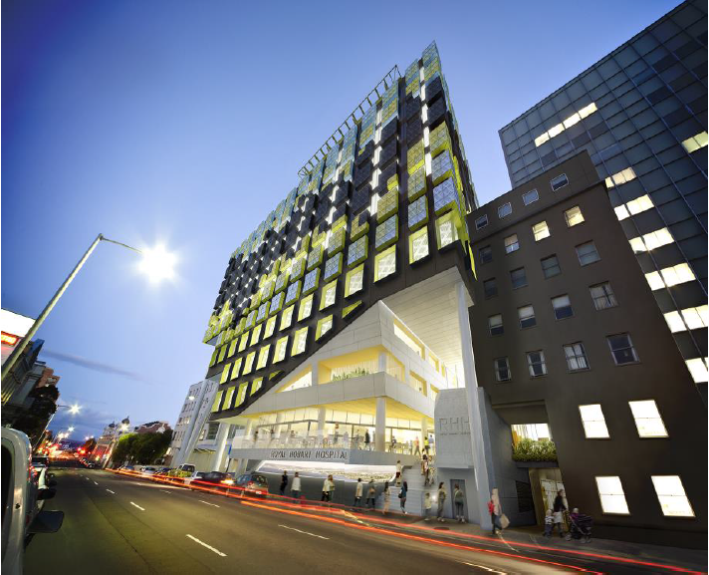

Fig.1 Royal Hobart Hospital K-Block

Stage 2: City Campus Development – interim expansion and refurbishment works
The RHH Masterplan 2020-2050 identifies the following works to start before or after K-Block occupation to support the ongoing operation of the RHH while the larger capital development works in future stages are progressed:
- Improved lift infrastructure
The installation of an additional dedicated patient lift to be located externally adjacent to Blocks J and H, connecting the Emergency Department (ED), Medical Imaging, ICU and J-Block, is required (Fig. 2). Currently, connectivity between the ED and other parts of the hospital relies heavily on aged lifts in Blocks C and H. These older style lifts are constrained by location, surrounding structure and little or no ability to upgrade to current bed lift size.
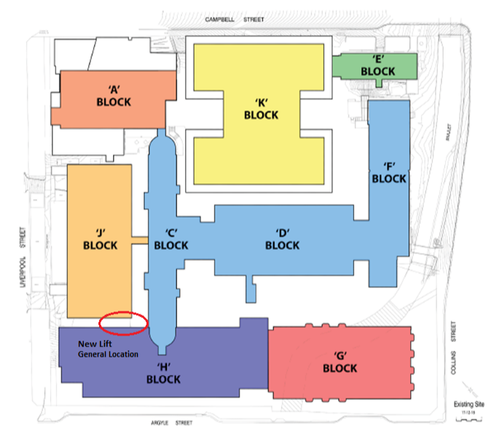
Fig.2 Proposed new lift – the final siting and interconnections with H and J Blocks will be determined as part of detailed project planning.
- A-Block refurbishment
Refurbishment of vacated wards and other maintenance works in A-Block (post K-Block completion) are needed to ensure the A-Block building infrastructure can effectively support clinical and support services (Fig. 3). In the RHH Masterplan 2020-2050, A-Block is retained with its long-term strategic role identified as an integrated cancer centre.
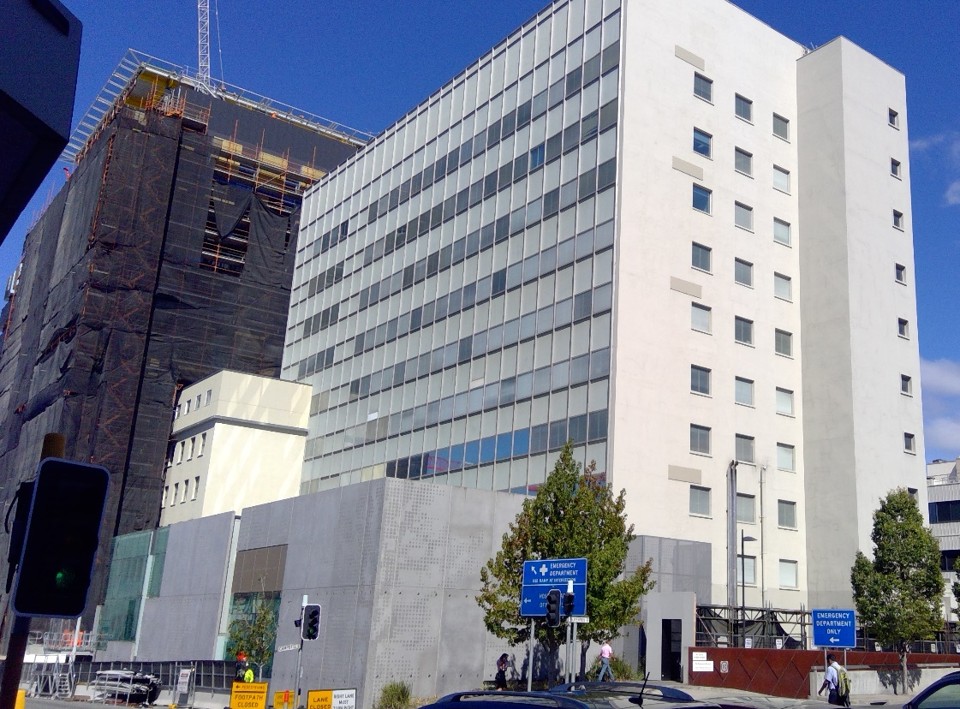
Fig.3 Royal Hobart Hospital A-Block
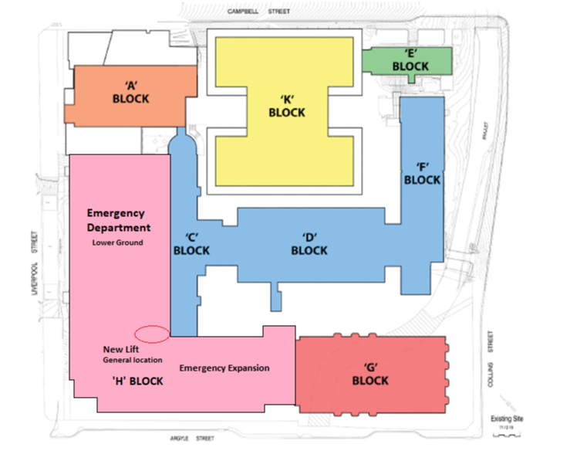
- Emergency Department expansion
There is a need to increase the physical footprint of the current ED until a new ED can be provided in future stages of the RHH Masterplan 2020-2050 (M-Block).
The RHH Masterplan 2020-2050 has identified an interim solution to expand the ED in its current location (Fig. 4).

Fi.4 Location of existing Emergency Department with expansion into H Block (shown in pink)
The ED expansion will provide:
  - Increased points of public access (access via Argyle Street and Liverpool Street).
  - Greater capacity for streaming of two different and discrete care areas.
  - Appropriate separation of ambulance and ambulatory presentations.
  - Discrete mental health safe assessment unit and support areas.
  - Separation of adult and paediatric treatment spaces to meet current needs.
  - Additional consult and interview spaces to meet demand.
  - Access to proposed new lift for dedicated patient transport to Medical imaging, ICU and J-Block.
These works are contingent on the allocation and fit-out of appropriate space for the Paediatric Outpatients service which would be displaced by expansion of ED. Initial scoping indicates the ability to accommodate this service in either A-Block or J-Block but consultation with clinical leaders is needed to progress this scoping work.
J-Block inpatient services
The relocation of mental health services to K-Block provides an opportunity to review the future use of J-Block in the short and long term (Fig 5). In the interim, it is recommended that the vacated space be reconfigured and fitted-out for inpatient clinical care to maximise capacity and utility of this space.
Currently only one half of one floor (2J) has the necessary infrastructure to provide generic clinical care (medical gases etc). The remainder has not been fitted out in this way as it has been used for mental healthcare. To be useable by services other than mental health, 3J and the remaining half of 2J will need fitting out.
There are several clinical services that could be accommodated in the refurbished J-Block. However, during the masterplan review consultation process, it was identified that Cardiology Services (currently occupying 2D, a clinical space nearing end of life and with near irremediable clinical risk issues) would need relocation and it is likely that floor 2 of J-Block offers the best appropriate interim solution.
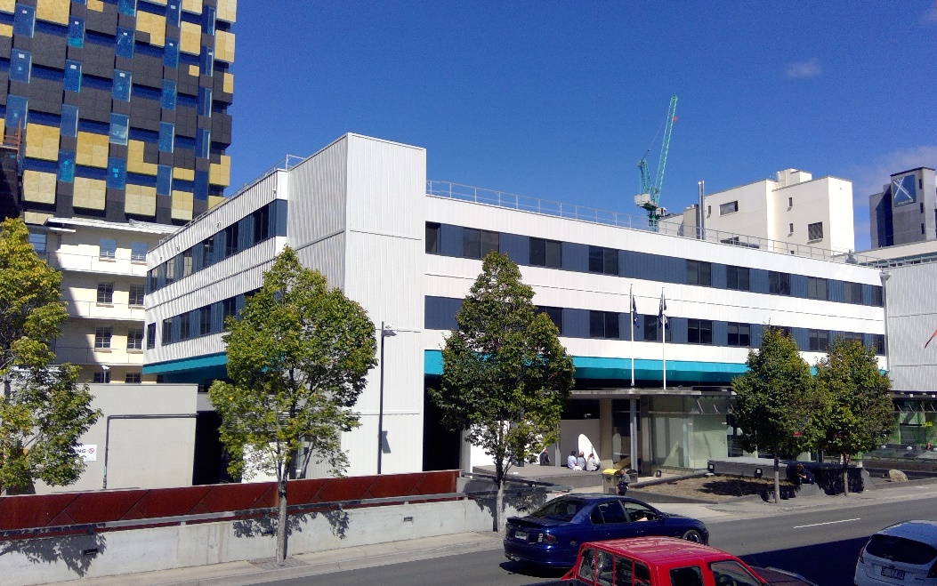
Fig.5 Royal Hobart Hospital J-Block

- Intensive Care Unit (ICU) expansion
Expansion of ICU is needed to deliver on the Government’s commitment for an additional 10 ICU beds by 2024.
A concept design has been developed to expand ICU in its current location until the next stage of the City Campus redevelopment can occur. This option would involve expansion into H-Block using space vacated by the move of Neurosurgery to K-Block (Fig. 6).
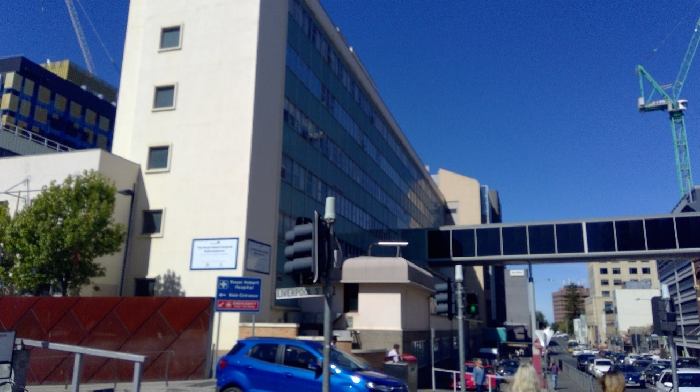

Fig.6 Royal Hobart

Hospital H-Block (ICU on the first floor)
The RHH Masterplan 2020-2050 delivers a further expansion opportunity in future stages of the City Campus development, with the building of L-Block (refer page 16).

Stage 3: RHH Repat Campus Development
The RHH Masterplan 2020-2050 recommends the development of the Repatriation Hospital site as a dedicated campus of the RHH, with clinical critical mass and appropriately selected services, such as sub-acute and mental health services (Fig. 7).
The proposal to consolidate the RHH Repatriation site as second campus of the RHH is considered by stakeholders as a genuine and unique opportunity to create a linked campus model that supports more efficient and effective patient care and flow, and which better meets the needs of consumers and staff.

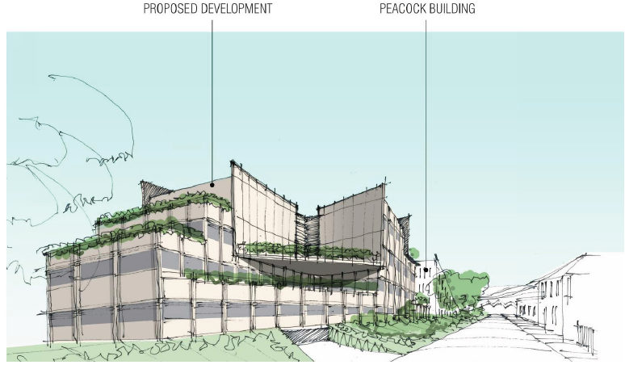
Fig. 7 Conceptual drawing - RHH Repatriation Campus Development (view from Hampden Road)
The proposed design of the Repatriation Campus in RHH Masterplan 2020-2050 aims to:
  - create a critical mass of services that supports a 24-hour sub-acute and mental health multi-disciplinary inpatient and outpatient facility
  - provide clinical and support services that can be relocated from the RHH site
  - provide outpatient clinic and other spaces that reduce the need for outlying and leased spaces (eg Wellington Centre and Telstra Building) to a consolidated location
  - provide additional carparking
  - continue use of existing buildings while constructing new facilities in staged sequence.
The Taskforce recommends acceptance of the proposal to develop the RHH Repatriation Campus as Stage 3 of the RHH Masterplan 2020-2050.

The Taskforce also recommends the acceptance of the proposed concept design of the RHH Repatriation Campus (Fig. 8), noting that the mix and configuration of services is indicative only and needs extensive planning and consultation with stakeholders. For example, advice from the Chief Psychiatrist and other mental health clinical leaders on the concept drawings is that the preferred location of mental health services is on the Ground Floor of the development.
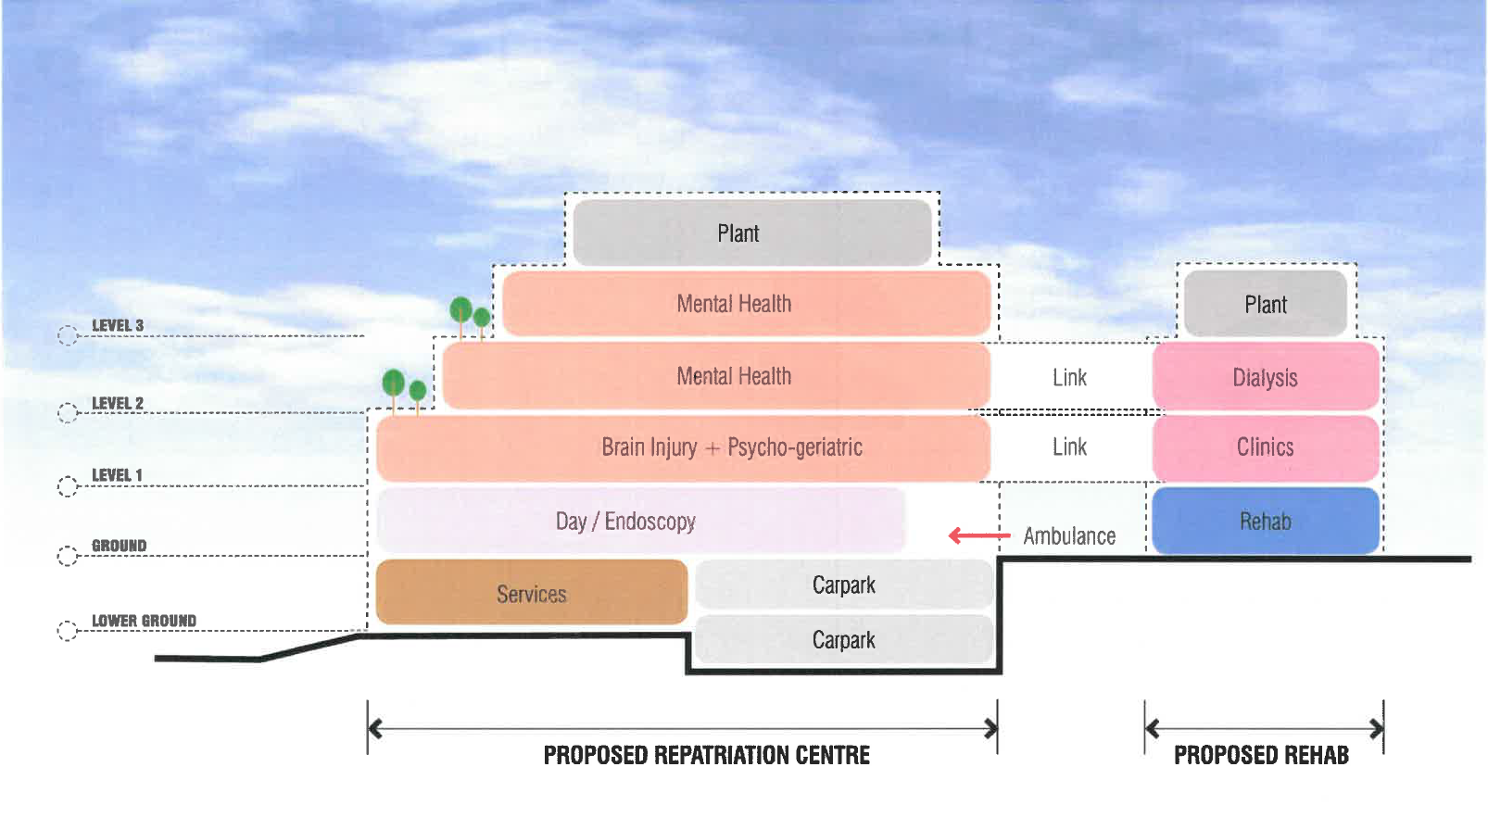
Fig. 8 Conceptual RHH Repatriation Campus Development - Section

Stage 4: RHH City Campus Development – L-Block
The RHH Masterplan 2020-2050 recommends that the staged redevelopment of the RHH City Campus continues after the development of the RHH Repatriation campus, with the next stage to be the new L-Block on the corner of Campbell and Collins Streets, with the same height profile as K-Block (Fig. 9). To allow for L-Block construction, E-Block and part of F-Block would be demolished.
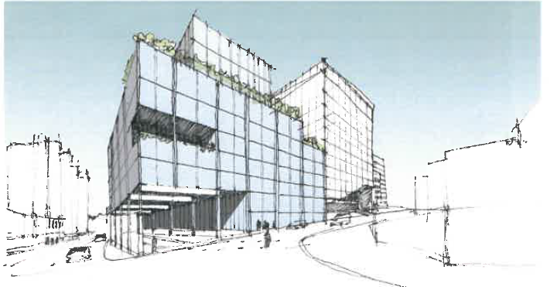
Fig. 9 Conceptual drawing - Proposed L-Block (view from corner of Collins and Campbell Streets)
L-Block would provide physical linkages with K-Block and D-Block and is proposed to house the following clinical and support services: Mortuary; Pharmacy; ICU expansion; Cardiology expansion; Operating theatres expansion; Pathology (contiguous with current Pathology service in F-Block); Clinical School plus teaching, education, research; administration and outdoor spaces (Fig. 10).
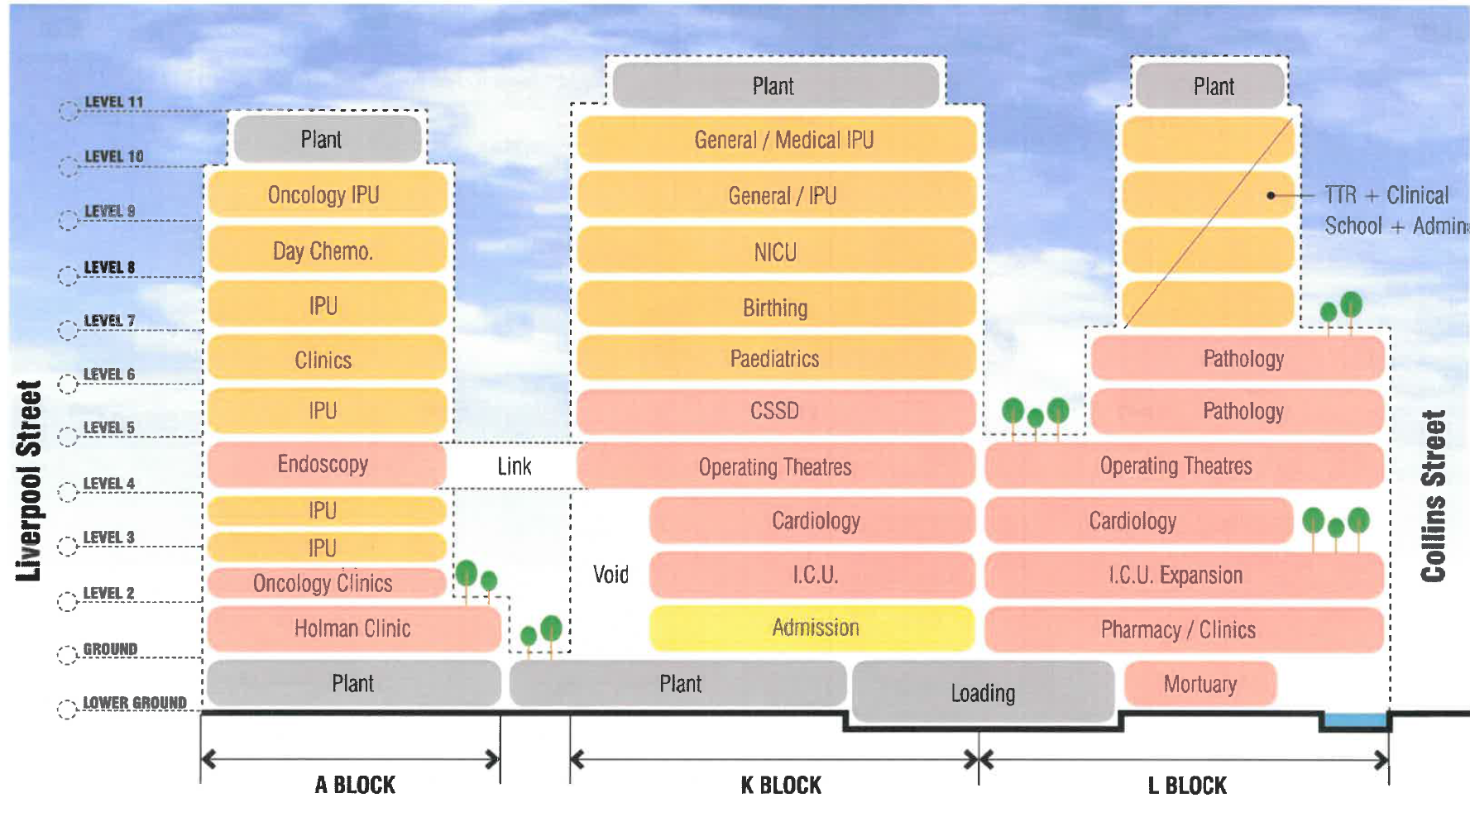
Fig. 10 – RHH Masterplan 2020-2050 Blocks A, K and L – section (after redevelopment of RHH Repat Campus and decanting of relevant services
Importantly, construction of and decanting into L-Block would empty D-Block and the remainder of F-Block and enable their demolition to allow for the next stage of construction. The tapered footprint of L-Block above Level 6 maintains appropriate separation between the upper levels of the two blocks due to inpatient wards occupying those upper storeys of K-Block, addresses the identified need for on-site teaching education and research space, and will likely reduce the overall construction costs of the block.

Stage 5: RHH City Campus Development – M-Block
The next stage, M-Block would follow and would be the same height profile as K-Block and L-Block (Fig. 11). M-Block consolidates key critical clinical services providing connectivity across the site. It is proposed to include:
  - Emergency Department
  - Ambulance parking and drop off
  - Future internal roadway
  - Medical Imaging
  - Allied Health
  - Operating theatre and day surgery
  - Up to seven levels of inpatient units/outpatient space, including rapid assessment and management unit (RAMU)
Given potential changes in demand and model of care between now and construction of M-Block, detailed layout and usage decisions are not currently possible other than at the highest level.
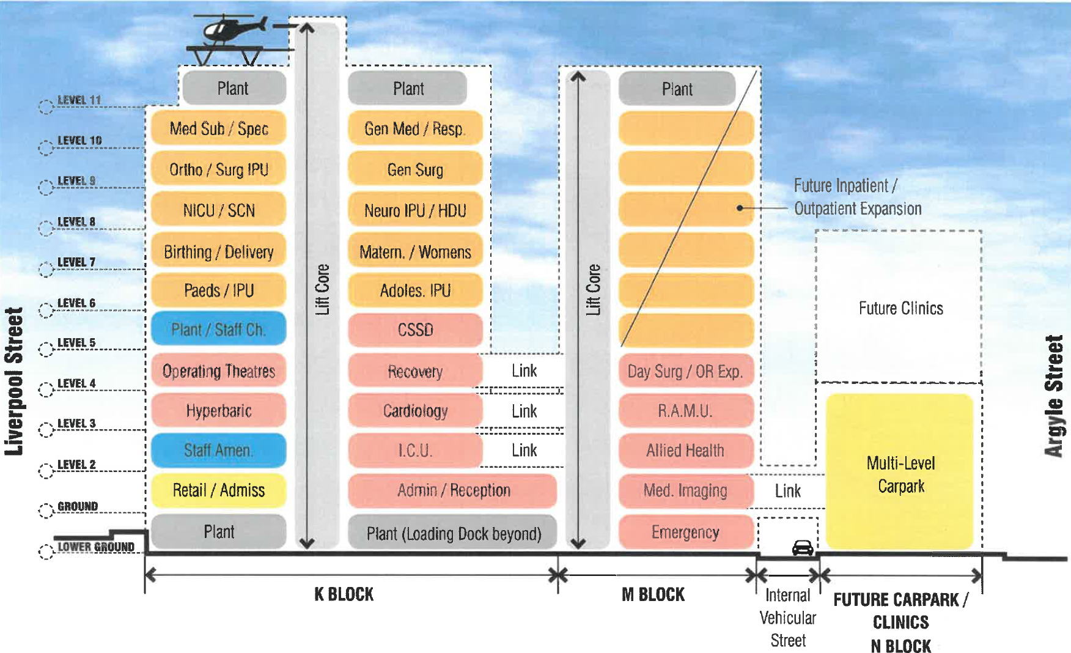
Fig. 11 – RHH Masterplan 2020-2050 Blocks K, M and N - section

Stage 6: RHH City Campus Development – N-Block
In the next stage, N-Block is proposed to be built to deliver on-site carparking and additional expansion space for future clinics (Fig. 11). This would also enable many services occupying leased off-site locations to be brought back on site, increasing operational efficiency and decreasing recurrent costs. The construction of N-Block would require the consideration of heritage implications of any changes to C-Block.
Given potential changes in demand and model of care between now and construction of N-Block, detailed layout and utilisation decisions are not currently possible other than at the highest level.

Other considerations

Levels 2 and 3 of K-Block
Stage 1 of the RHH Masterplan 2020-2050 is the completion of the RHH’s new inpatient facility (K-Block). The contractually agreed configuration and fit-out of K-Block includes Mental Health Services occupying Levels 2 and 3 of K-Block (K2/3). K-Block fit-out is significantly progressed. The RHH Redevelopment’s Managing Contractor has scheduled the practical completion of the new block before the end of 2019.
In mid-2018, the Minister for Health, at the request of the AMA, agreed to consider a proposal by the Tasmanian branch of the AMA to change this configuration - namely to relocate ICU from its current location to K2/3 and retain Mental Health Services in J-Block until a purpose-built facility is available. The Minister for Health requested the Taskforce review and provide advice to him on this request as part of the Masterplan review and update.
In recent weeks, a concern was raised in the media about the distance between the new helipad and the ICU in its current location and its impact on safe transfer of patients. This concern was also investigated by the Taskforce.
In assessing the proposal to locate ICU in K-Block ahead of the planned sequencing schedule, the Taskforce examined both the immediate and long-term plans for the development of ICU and Mental Health Services, the positive and negative impacts on each of the services of either relocation or retention of their current locations, and the timing and flow on effects of any amendments on the following key areas:
  - Quality and safety of patient care
  - Consumer, family and carer experience of care
  - Appropriate spending of public monies
  - Staff wellbeing
  - Cost and disruption to services
  - Flow-on effects of changes to the long-term vison of the development of the RHH precinct.
The Taskforce also carefully considered the views of clinicians, the RHH Executive, Statewide Mental Health Services, THS Executive, the Southern Reference Group and RHH Redevelopment Project team in assessing the proposal and informing its advice.
The Taskforce concluded that there was no evidence of net benefit to the Tasmanian community to amend the current configuration of K-Block to accommodate the proposal. The costs (including patient care, financial, staff well-being and time) for retaining Mental Health Services in J-Block were considered to outweigh any expected benefit of improving connectivity of ICU with services to be in K-Block. Other valid options for ICU expansion exist within its current location, and the positive benefits of ICU occupying K2/3 were outweighed by the negative impact of continuing the delivery of Mental Health Services from its current location in J-Block.

Key considerations:

K-Block configuration
  - The location of services in K-Block was developed in consultation with clinicians and key stakeholders over many years, and later confirmed by these stakeholders during the 2014 Rescue Taskforce.
  - Clinically-driven changes to scope included fast-tracking the installation of the helipad and hyperbaric chamber (slated for the second stage of the 2011 Master Plan), minor design changes to the Women’s and Children’s precinct and a redesign of levels 2 and 3 to maximise floor space and allow improved amenity for delivering Mental Health Services, including more outdoor space, for the acute mental health wards on those levels.
  - Any changes to the agreed configuration would result in significant cost implications and delays in occupying K2/3 while planning and construction occurs.

Expansion of ICU
  - Accommodating an expanded ICU in K-Block is the ultimate intention in future stages of RHH development.
  - In Stage 4 (L-Block), the ICU would form part of the K-Block vertical stack, increasing connectivity with new theatres and medical wards.
  - Until this stage is delivered, there is capacity to expand the ICU in its current location to deliver additional beds as committed by Government. This forms part of the recommended works in Stage 2 of the RHH Masterplan 2020-2050.

Current location of ICU
  - The ICU is sited close to the ED and Department of Medical Imaging, and any move to K-Block would lead to issues related to transporting critically ill patients from the Emergency Department, and to Computed Tomography (CT) or Magnetic Resonance Imaging (MRI).
  - The site has reasonably sized areas for family interview, staff amenities and for clinical handover, all present on the same floor. This could not be guaranteed in any development of ICU on K 2/3.
  - It also has close access to medical and nursing offices including research and education.

Connectivity of ICU with helipad
  - There is no evidence of advantage in having the ICU closer to the helipad.
  - All 12 K-Block lifts have a priority override function and the estimated time for full transit from the dedicated helipad lift to the ground floor is less than 20 seconds. The corridor distances between the K-Block lift exit and the emergency department or the lift to ICU are 100 and 140 metres respectively. At an average walking speed that’s about two to three minutes. Moreover, admission statistics provided by the Department of Health for 2017 and 2018 indicate that no more than three primary aeromedical retrievals were transferred directly from the helicopter to ICU.
  - Patients requiring time-critical transfer from the Helipad to a clinical service almost invariably need to go to the operating theatres, which will be a direct lift ride from the helipad. Even those who do end up going from helipad to ICU almost always do so via clinical assessment in the ED.
  - Matters of patient safety and quality of care remain the highest priority of the Taskforce and it is recommended that as part of the K-Block commissioning phase, models of care and protocols for patient transfer across the RHH are reviewed by the RHH Executive in close consultation with clinical and support staff. The Taskforce also recommends regular review of these protocols to ensure the systems designed for safe patient transfer are in place and working well.

Location of Mental Health Services
  - The Taskforce accepts that a purpose-built facility for Mental Health Services is the preferred long term option. This was a feature of Stage 2 of the 2011 Masterplan, which had Mental Health Services moving to K-Block while L-Block was being constructed and is now provided for in the updated RHH Masterplan 2020-2050 through the redevelopment of the Repatriation Campus (Stage 3) as a sub-acute and mental health campus of the RHH.
  - The use of J-Block for Mental Health services was specifically intended as the first of two interim steps to the long-term solution of a purpose-built mental health facility, with the move to K2/3 the second step.
  - The retention of Mental Health Services in J-Block until Stage 3 of the RHH Masterplan 2020-2050 presents significant challenges and risks.
  - K2/3 offers an immediate and significant opportunity to improve the facilities for provision of acute Mental Health Services to provide safe, efficient and effective patient care, contemporary models of care and improved staff wellbeing.
  - The Taskforce was not confident that any amendments to J-Block would adequately improve environment and amenity to justify an extended occupation of J-Block, even with the shortest possible timeframe for funding and constructing a custom-built facility at the Repatriation Campus.

Planning for 250 beds
The review of the 2011 Masterplan considers the physical space and infrastructure required to support the Government’s commitment to provide funding for an additional 250 beds across Southern Tasmania, to be opened and fully staffed by 2024. The review also considers the existing $28.1 million budgetary allocation over five years for necessary ward upgrades to support additional beds. The scope of the review does not extend to a determination on the need and mix of beds or the staging of the bed openings.
While commissioning for the opening of K-Block is underway, a full plan for the mix of beds and staging of bed openings to 2024 will be contingent on three key drivers:
- Direction from Government on the next stage of development for the RHH and Repatriation Hospital precincts
- Detailed clinical service planning informed by robust need, demand, capacity and utilisation analysis to inform the funding allocation and commissioning of additional beds in the acute care system
- Engagement and consultation with consumers, clinicians, staff, other service providers
Through the masterplanning process the Taskforce identified an opportunity to strengthen planning for the additional beds, including a clear governance structure to support decision-making.
The Taskforce recommends that it form a working group, to develop a comprehensive plan for the additional beds, including the commissioning of new beds in K-Block and determination of the use of vacated spaces post K-Block completion. The working group would comprise representatives from:
  - Clinical Planning Taskforce
  - THS Executive
  - RHH Executive
  - Statewide Mental Health Services
  - Asset Management Services (DoH)
  - Planning, Purchasing and Performance (DoH)
  - Corporate Services (DoH)
  - Heath Workforce Planning Unit (DoH)
The plan would be developed by the working group, endorsed by the Taskforce and approved by the Secretary, DoH.
The broader remit of the Taskforce includes overseeing the development of a long-term plan to set the future direction and strategy for Tasmania’s health system to meet the health challenges of an ageing population, increasing incidence of chronic diseases, workforce challenges and ageing infrastructure.
The Taskforce acknowledges that this work will facilitate delivery of the Government’s commitment for additional beds in the public sector. The Taskforce will work closely with the RHH to ensure that changes in future direction of health service delivery in Tasmania are reflected in the 2024 bed plan.

Next steps
Subject to the acceptance by Government of the RHH Masterplan 2020-2050 and interim works, the following next steps are recommended to further develop the plans for continued development of the RHH precinct:
  - Proof planning and scheduling detailed stakeholder engagement for interim expansion and refurbishment works.
  - Development of schedules of accommodation for Repatriation Campus and City Campus (Blocks L and M).
  - Engineering and infrastructure inputs.
  - Cost planning inputs.
  - Further stakeholder engagement including Council and Authority inputs to both sites.
  - Complete measured drawings and asset reviews of both sites, as a component of interim Strategic Building Infrastructure Maintenance Plan.
  - Development of business cases to support investment in interim and long-term capital works.
Underpinning this work will be rigorous health service planning based on data and information on population need, projected growth in demand and activity and strong engagement with consumers, the community, service providers and other key stakeholders.
Any future development of the RHH precinct will also need to consider the ongoing role of the RHH as the principal tertiary referral hospital and as part of an integrated statewide public health service.

Acronyms
AMA – Australian Medical Association
AMS – Asset Management Services
ANMF – Australian Nursing and Midwifery Federation
APU – Assessment and Planning Unit
CPT – Clinical Planning Taskforce
CT/MRI – Computer Tomography / Magnetic Resonance Imaging
DoH – Department of Health
ED – Emergency Department
HACSU – Health and Community Services Union
ICU – Intensive Care Unit
LGH – Launceston General Hospital
MET – Medical Emergency Team
MSA South – Medical Staff Association South
RGH – Repatriation General Hospital
RHH – Royal Hobart Hospital
SRG – Southern Reference Group
STH – Silver Thomas Hanley
UTas – University of Tasmania

