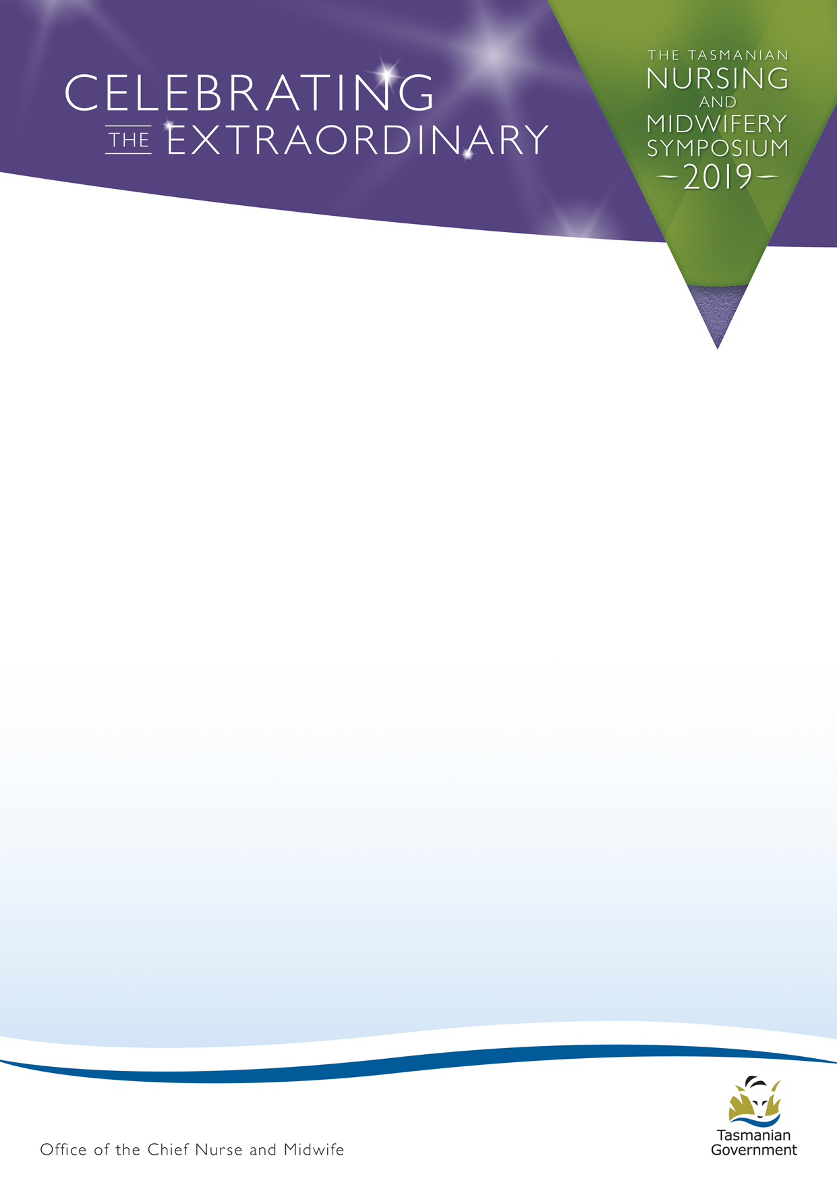

POSTER DISPLAY SUBMISSION
Please complete all sections of the form and email to naomi@eventsphere.com.au
no later than 11.59pm Thursday 31 January 2019.
If you have any questions, please do not hesitate to call Naomi on 0439 336 511.
Your intention to submit a poster must be received on time to be considered for the poster display of the
Tasmanian Nursing and Midwifery Symposium 2019. (www.dhhs.tas.gov.au/healthprofessionals/nursing/conferences_and_events/tnm_symposium)
Authors:
Authors Affiliation:
NOTE: Posters will be on display for the full day at the Symposium, poster authors will not be required to talk to the information. For posters to be included in the Symposium display, poster authors must register for the Tasmanian Nursing and Midwifery Symposium. Poster authors will be required to print their own posters for the Symposium.
Poster Category – (please check the applicable category):
- General extraordinary category
- Outside the box – extraordinary ideas
- Two heads are better than one – extraordinary collaboration
- An ordinary day – extraordinary stories

Poster Specifications
Size: Maximum of A0 (width 841cms x height 1189cms). Must be in portrait orientation.
Font: All text can be read from a normal distance (i.e. can be read at a distance of 1.2 metres)
Title:
Which work group does your poster represent:
Key contact name for the poster:
Key contact email:
Key mobile contact:

